
./
GENESIS - Learning Outcome & Mini-project Summary Report

Ver. Rel. No. | Release Date | Prepared. By | Reviewed By | To be Approved | Remarks/Revision Details
1. | 14/04/2021 | Jasleen Kaur Sethi/99003720
Details

Contents
Contents 3
Miniproject -1 [Team/Individual] 4
Module/s 4
Topic and Subtopics 4
Objectives & Requirements 4
Design 4
Test Plan 4
Implementation Summary 4
Video Summary 4
Git Link 4
Git Dashboard 4
Summary 4
Individual Contribution & Highlights 5
Summary 5
Challenges faced and how were they overcome 5
Future Scope (If applicable) 5
Miniproject -2 [Team/Individual] 6
Module/s 6
Topic and Subtopics 6
Objectives & Requirements 6
Design 6
Test Plan 6
Implementation Summary 6
Git Link 6
Git Dashboard 6
Summary 6
Individual Contribution & Highlights 6
Summary 6
Challenges faced and how were they overcome 6

Miniproject -1 [Team] : Applied SDLC – Building a Calculator

Module/s
The module linked to the mini project is SDLC

Topic and Subtopics
The core topics and subtopics being implemented are:

Software Development Life Cycle

The basics of the Software Development Life Cycle. It includes the flow of development in a product in the industry.
- It starts with finding the various high level and low-level requirements that are required for building the product. Then the high level and low-level design is built for brief visual understanding of the working of the product.
- The software for the product is then implemented in sync with the requirements.
- The implemented code is then tested with the method of unit testing and integration testing.
- After all the implementation and testing, it is finally deployed in the market.

Unified Modelling Language(UML) Diagrams

The various structural and Behavioral diagrams were studied and implemented for designing the product according to the requirements provided.
The various structural and Behavioral diagrams learnt were:
Structural Diagrams:

    - Class Diagram
    - Component Diagram
    - Object Diagram
    - Deployment Diagram
    - Package Diagram
    - Profile Diagram
    - Composite Structure Diagram
Behavioral Diagrams:

    - Use Case Diagram
    - Activity Diagram
    - State Machine Diagram
    - Sequence Diagram
    - Communication Diagram
    - Interaction Overview Diagram
    - Timing Diagram

Objectives & Requirements
Objective:
To build the software development cycle of a semi-engineering calculator. It fulfils the numerous high-level and low-level requirements of the various features involved in semi-engineering such as log, antilog, exponents, roots, LCM and GCD functions. It then explores about the various test cases that should be taken in consideration such that all requirements are taken care of. In the end, we build the codes that follow all the requirements and design efficiently as per them.

Requirements:
High Level Requirements:

ID | Requirements | Description | Status
HL001 | ARITHMETIC OPERATIONS | BASIC ARITHMETIC CALCULATION – Addition, Subtraction, Division and multiplication | IMPLEMENTED
HL002 | LOG ANTILOG FUNCTIONS | SOLVING POWER FUNCTIONS AND LOG/ANTILOG OPERATIONS | IMPLEMENTED
HL003 | TRIGONOMETRIC FUNCTIONS | SINE, COSINE, TAN FUNCTIONS | IMPLEMENTED
HL004 | PERMUTATION & COMBINATION | PERMUTATION AND COMBINATION FORMULAE OUTPUTS | IMPLEMENTED
HL005 | CONVERSIONS OF UNITS | UNIT COVERSIONS FOR TEMPERATURE AND VARIOUS LENGTH UNITS | IMPLEMENTED
HL006 | FACTORIAL & POWER | FACTORIAL AND POWER OF THE POSITIVE NUMBERS | IMPLEMENTED
HL007 | LCM & GCD | LCM and GCD OF THE POSSIBLE REAL NUMBERS | IMPLEMENTED
HL008 | PRECEDENCE | CALCULATION ACCORDING TO THE PRECEDENCE OF THE FUNCTIONS | IMPLEMENTED
HL009 | STORE AND RECALL | CALCULATOR TO STORE AND RECALL RESULTS | IMPLEMENTED
HL0010 | PRECISION | RESULTS SHOULD BE ACCORDING TO PRECISION | IMPLEMENTED

Low Level Requirements:

Arithmetic Operations:
ID | Requirements | Description | Status
LL001 | Addition | Taking two numbers as input and adding them | Implemented
LL002 | Subtraction | Taking two numbers as input and subtracting them | Implemented
LL003 | Multiply | Taking two numbers as input and multiplying them | Implemented
LL004 | Divide | Taking two numbers as input and dividing them | Implemented

Log and Antilog operations
ID | Requirements | Description | Status
LL003 | Logarithm | Taking one number as input with base as 10 and finding its log output | Implemented
LL004 | Anti-logarithm | Taking one number as input with base as 10 and finding its antilog output | Implemented

Trigonometric Operations

ID | Requirements | Description | Status
LL005 | Sine Functions | Finding the sine of a number | Implemented
LL006 | Cos Functions | Finding the cos of a number | Implemented
LL007 | Tan Functions | Finding the tan of a number | Implemented

Permutation and Combination

ID | Requirements | Description | Status
PER_1 | n<R | shows error when N<R | Implemented
PER_2 | Formulae calculation Permutation | finds permutation using the formulae | Implemented
COM_1 | n<R | shows error when N<R | Implemented
COM_2 | Formulae calculation combination | finds combination using the formulae | Implemented

Conversion of Units
ID | Requirements | Description | Status
COU_1 | Length conversion | converts input from cm to m &km | Implemented
COU_2 | Temperature conversion | converts user input from Celsius to Fahrenheit | Implemented
COU_3 | Degree to radian conversion | converts one user input from degree to rad at a time | Implemented

Factorial and Power
ID | Requirements | Description | Status
Fac_1 | Factorial | Finding factorial of the given number | Implemented
pre_1 | Library | Math library file will be required in coding section. | Implemented
pre_2 | power function | Requirement of power function while executing this section of program. | Implemented
pre_3 | Data type | Must contain best suited data types else show | Implemented
pre_3 | Boundary limit | Limit exceeds. | Implemented

LCM and GCD Functions

ID | Requirements | Description | Status
LL0011 | LCM | Finding the least common multiple of the possible real numbers | Implemented
LL0012 | GCD | Finding the greatest common devisor of the possible real numbers | Implemented

Precedence
BOD_1 | Bracket Type | For more than 1 operation, brackets ((),[],{}) should be identified and executed first. | Implemented
BOD_2 | Bracket order 1 | The bracket order (), {}, [] is to be followed. | Implemented
BOD_3 | Bracket order 2 | For more than 1 operation, powers and roots should be identified and executed after brackets. | Implemented
BOD_4 | Bracket order 3 | For more than 1 operation, Division should be identified and executed after exponents and roots. | Implemented
BOD_5 | Bracket order 4 | For more than 1 operation, Multiplication should be identified and executed after Division. | Implemented
BOD_6 | Bracket order 5 | For more than 1 operation, Multiplication should be identified and executed after Division. | Implemented
BOD_7 | Bracket order 6 | For more than 1 operation, Addition should be identified and executed after Multiplication. | Implemented
BOD_8 | Bracket order 7 | For more than 1 operation, subtraction should be identified and executed after Addition. | Implemented

Store and Recall Functions

ID | Requirements | Description | Status
BOD_1 | Stored value | - Capable of storing values for 50 days | Implemented
BOD_2 | MC function | - Pressing ‘MC’ and 0 clears the memory | Implemented
BOD_3 | Memory storage | - Stores up to 5 memories. | Implemented
BOD_4 | Memory style | - Show all memories in a first in last out style after every click | Implemented

Precision

ID | Requirements | Description | Status
pre_1 | Multiplication power | When multiplication of 10 digit it should show in power of ten | Implemented
pre_2 | divided by 0 | When value is divided by zero then zero then it should through error. | Implemented
pre_3 | Boundary Precision | user puts value of more than 10 then it must not except more than that and print limit exceeds as an output. | Implemented
COM_3 | Formulae calculation combination | finds combination using the formulae. | Implemented
COM_1 | n<R | shows error when N<R | Implemented

Design

High Level Design

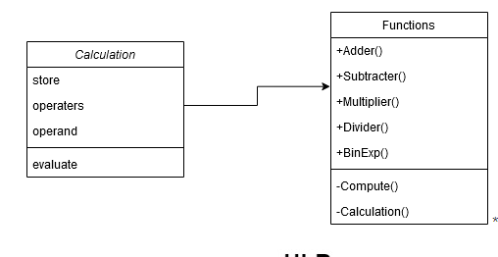

Structural – Class Diagram

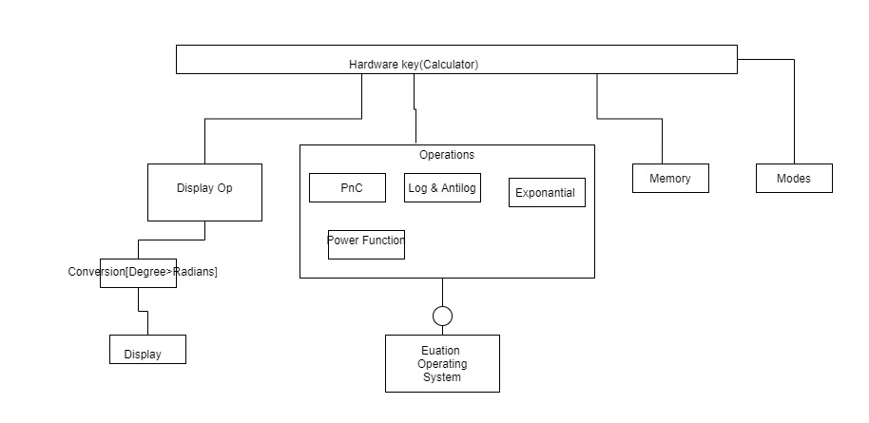
Structural – Component Diagram

Low Level Design

Arithmetic Operations
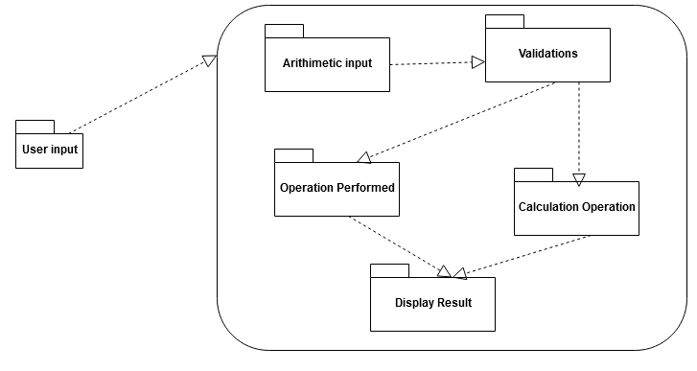
Structural - Package Diagram

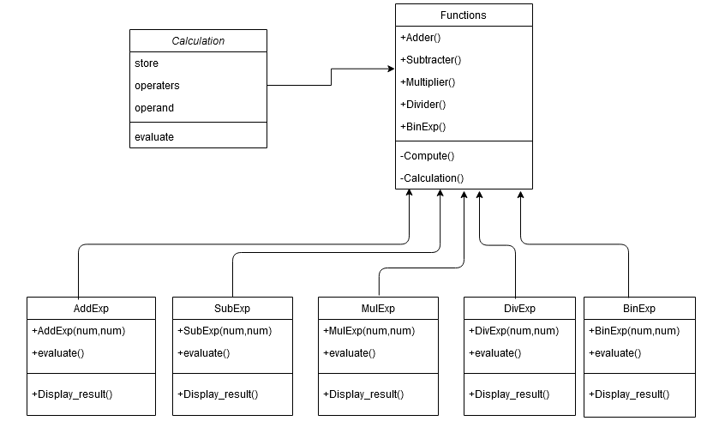
Behavioral – Object Diagram

Store and Recall:

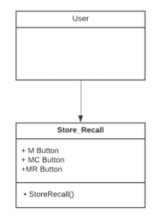
Structural – Class Diagram
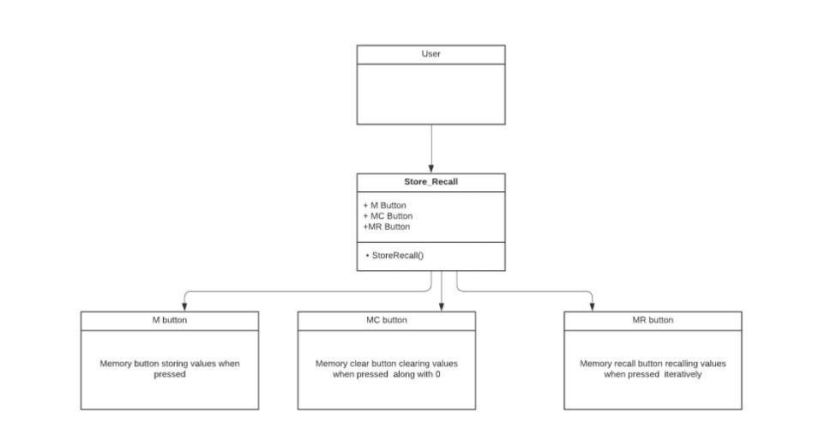
Behavioral – Object Diagram

Power Function

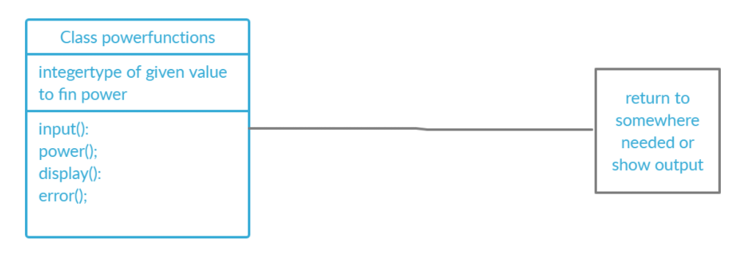

Structural – Class Diagram

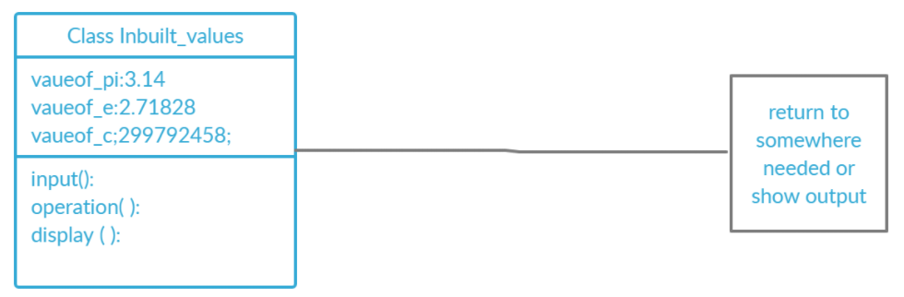

Behavioral – Object Diagram

Trigonometric Functions

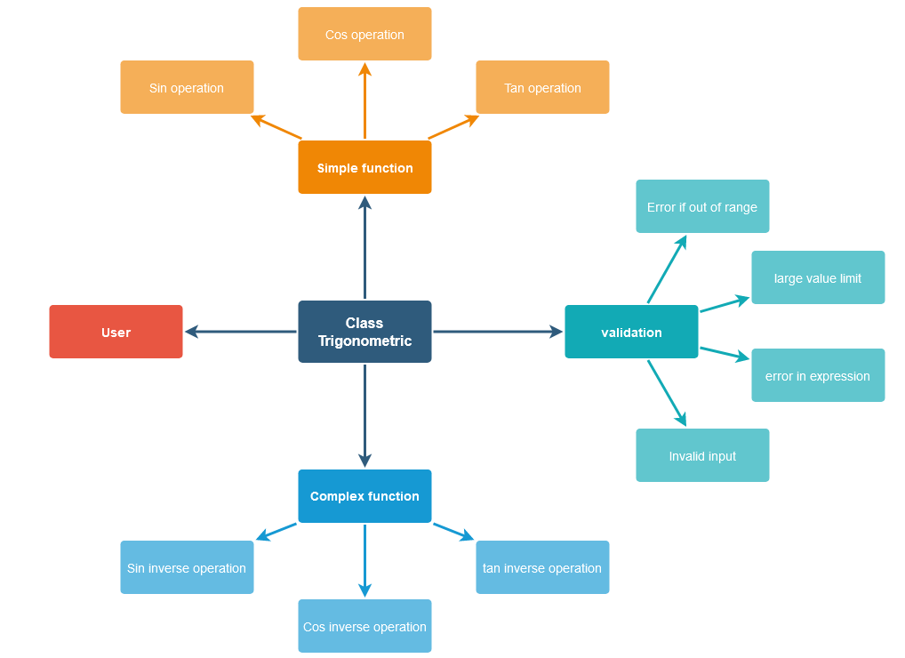
Structural – Component Diagram
Permutation and Combination
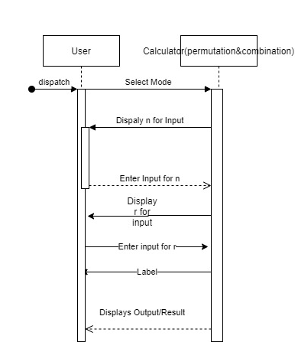
Behavioral – Sequence Diagram
Precision
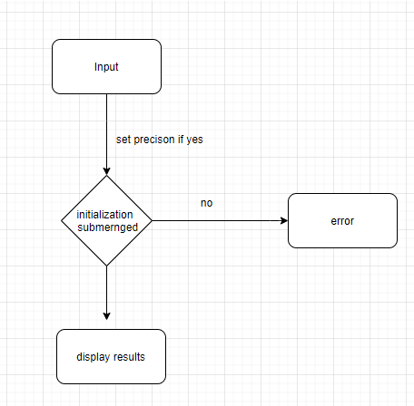
Behavioral – Activity Diagram

Precedence

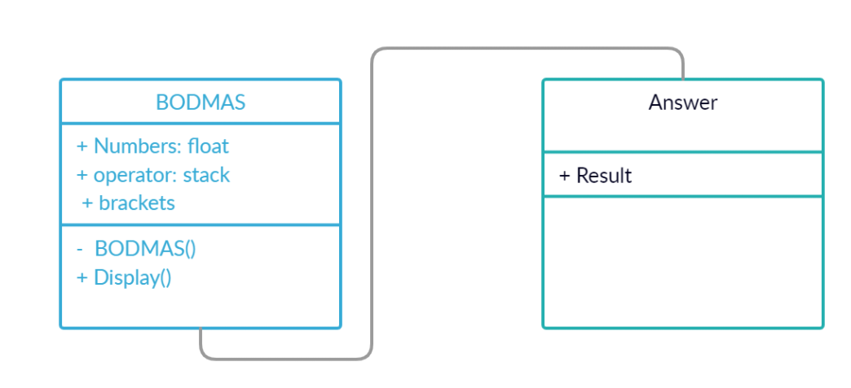
Structural – Class Diagram
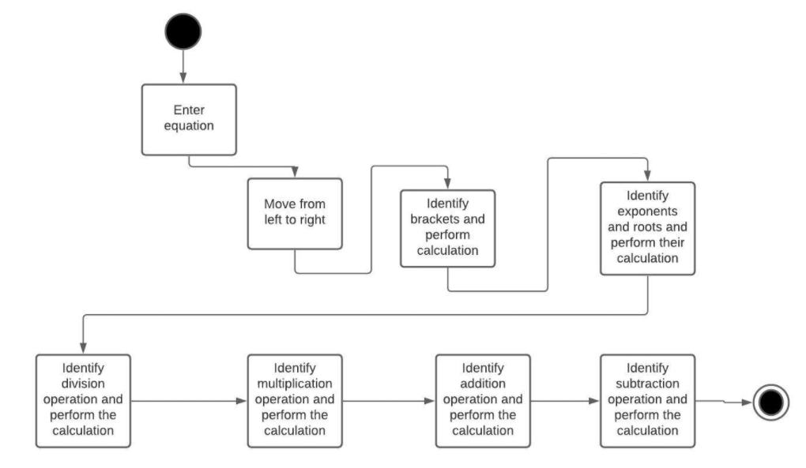
Behavioral – Activity Diagram

Test Plan

High Level Test Plan
Test ID | Description | Expected Input | Expected Output | Actual Output | Type of test
L_01 | Verify that BODMAS is applied in case of complex queries and the correct result is returned. | 24+3*2 | 30 | 30 | Requirement based
L_02 | Addition of 2 or more numbers | 20+30 | 50 | 50 | Scenario based
L_03 | Sequential incorrect parameter | 2+4*3. y | 20 | Error | Boundary based
L_04 | Out of range check | addition if exceed 15 digit numbers | any output | Result out of range | Requirement based
L_05 | Sequential incorrect parameter | 2+4*3. y | 20 | Error | Boundary based
L_06 | Two symbols cannot be between numbers | 3++5 | 2 | Invalid Format | Scenario based
L_07 | Trigonometry Sine value | sin(x) | sin x | sin x | Boundary based

Low Level Test Plan

Arithmetic Operations

Test ID | Description | Expected Input | Expected Output | Actual Output | Type of test
L_0211 | Adding two negative numbers | num1=-750, num2=-7500 | result=-8250 | result=-8250 | Scenario based
L_0212 | Adding one negative number and one positive number | num1=10, num2=-20 | result=-10 | result=-10 | Scenario based
L_0213 | Adding one positive number and one negative number | num1=-98, num2=20 | result=-78 | result=-78 | Scenario based
L_0221 | Subtracting two positive numbers | num1=13, num2=4 | result=9 | result=9 | Scenario based
L_0222 | Subtracting positive number from a negative number | num1=-45, num2=6 | result=-51 | result=-51 | Scenario based
L_0223 | Subtracting two negative numbers | num1=-7985, num2=-7745 | result=-240 | result=-240 | Scenario based
L_0231 | Multiplying one positive number with one negative number | num1=-20, num2=3 | result=-60 | result=-60 | Scenario based
L_0232 | Multiplying one negative number with one positive number | num1=8745, num2=-83 | result=-725835 | result=-725835 | Scenario based
L_0233 | Multiplying two negative numbers | num1=-99, num2=-999 | result=98901 | result=98901 | Scenario based
L_0241 | Dividing by zero | num1=1, num2=0 | result=-1(for error) | result=-1 | Scenario based
L_0242 | Dividing two negative number | num1=-135, num2=-3 | result=45 | result=45 | Scenario based
L_0243 | Dividing negative number by positive number | num1=-28, num2=14 | result=-2 | result=-2 | Scenario based
L_0244 | Dividing positive number by negative number | num1=96, num2=-12 | result=-8 | result=-8 | Scenario based
L_0311 | Multiplying two 8 digit numbers | num1=100000000, num2=99999999 | result=-1 | result=-1(for Error) | Boundary based
L_0232 | Multiplying one negative number with one positive number | num1=8745, num2=-83 | result=-725835 | result=-725835 | Scenario based
L_0233 | Multiplying two negative numbers | num1=-99, num2=-999 | result=98901 | result=98901 | Scenario based
L_0241 | Dividing by zero | num1=1, num2=0 | result=-1(for error) | result=-1 | Scenario based
L_0242 | Dividing two negative number | num1=-135, num2=-3 | result=45 | result=45 | Scenario based

Precedence

Test ID | Description | Expected Input | Expected Output | Actual Output | Type of test
LLR_P_1 | First, the operators within brackets are executed in order of multiplication and subtraction order and then add operator outside bracket. | 14 + (8 – 2 × 3) | 16 | 16 | Logical test
LLR_P_2 | The terms inside {} are simplified followed by () and then operated with terms outside the bracket. | 1800÷10{(12−6)+(24−12)} | 3240 | 3240 | logical
LLR_P_3 | The terms inside () are simplified followed by {}, then [] and then terms are operated with the terms outside the bracket. | 1/2[{−2(1+2)}10] | -30 | -30 | Logical
LLR_P_4 | The terms inside () are simplified first followed by exponent and then terms are operated with the terms outside the bracket. | (2^9*2) + 9 / (e^3) | 1204.76983 | 1204.76983 | Logical
LLR_P_5 | An equation of the result of more than 8 digits is given by the user. | (10*5+100) *100 | Error: Out of range | Error: Out of range | Boundary Based
LLR_P_6 | Values up to 9 digits | 3+(3*4+5) *3/10+1 | Error: Out of range | Error: Out of range | Requirement based

Roots

Test ID | Description | Expected Input | Expected Output | Actual Output | Type of test
LLR_P_1 | Finding the square of given number i.e. find power of number will be 2. | 100^2 | 10000 | 10000 | logic based
LLR_P_2 | Finding the cube of given number i.e. find power of number will be 3. | 10^3 | 1000 | 1000 | logic based
LLR_P_3 | Finding the power of given number i.e. find power of number will be any number | 2^5 | 32 | 32 | logic based
LLR_P_4 | Finding the power of big number i.e. find power of number which results in digits more than 20 | 3^20 | 3.48x10^9 | 3.48x10^9 | Boundary based
LLR_P_5 | Finding the power of other then the numbers i.e. finding power of any operator or any other buttons | [^20Or +^60 | Error: Out of range | Error: Out of range | Requirement based

LCM and GCD
Test ID | Description | Expected Input | Expected Output | Actual Output | Type of test
LLR_P_1 | finding LCM of two positive numbers | 5,15 | 75 | 75 | logic based
LLR_P_2 | finding LCM of any one negative number | -72,120 | 360 | 360 | logic based
LLR_P_3 | finding LCM of one number as zero | 0,10 | Error | Error | logic based
LLR_P_4 | finding LCM of two large numbers | 100000,100000 | Out of range | Out of range | Boundary based
LLR_P_1 | finding GCD of two positive numbers | 5,15 | 5 | 5 | logic based
LLR_P_2 | Finding GCD of any one negative number | -72,120 | 20 | 20 | logic based
LLR_P_3 | finding GCD of one number as zero | 0,10 | Error | Error | logic based
LLR_P_4 | finding GCD of two large numbers | 100000,100000 | Out of range | Out of range | Boundary based

Permutation and Combination
Test ID | Description | Expected Input | Expected Output | Actual Output | Type of test
LLR_P_1 | find permutation using the formula | 3,2 | 6 | 6 | logic based
LLR_P_2 | finding permutations of large numbers | 180,179 | Error: large result | Error: large Result | Boundary based
LLR_P_3 | Permutation of numbers when n<r | 10,11 | Error | Error | requirement based
LLR_P_4 | find combination using the formula | 6,4 | 15 | 15 | logic based
LLR_P_5 | finding combination of large numbers | 180,179 | Error: large result | Error: large Result | Boundary based
LLR_P_6 | Combination of numbers when n<r | 4,6 | Error | Error | requirement based

Trigonometric Functions

Test ID | Description | Expected Input | Expected Output | Actual Output | Type of test
LLR_P_1 | Trigonometric Sine value of 0 | 0 | 0 | 0 | math.h file & Boundary based
LLR_P_2 | Trigonometric Cosine value of 0 | 0 | 1 | 1 | math.h file & Boundary based
LLR_P_3 | Trigonometric Tan value of 0 | 0 | 0 | 0 | math.h file & Boundary based
LLR_P_4 | Trigonometric Sine value of 90 | 90 | 1 | 1 | math.h file & Boundary based
LLR_P_5 | Trigonometric Cosine value of 90 | 90 | 0 | 0 | math.h file & Boundary based
LLR_P_6 | Trigonometric Tan value of 90 | 90 | not defined | not defined | math.h file & Boundary based
LLR_P_6 | Other than numeric values in trigonometric ratios | /,=,,&,;,', | error | error | math.h file & Boundary based

Store and Recall Functions

Test ID | Description | Expected Input | Expected Output | Actual Output | Type of test
LLR_P_1 | M button after 50 days | M button after 50 days | No memory found | No memory found | requirement based
LLR_P_2 | MC button clicked to select the value to clear and 0 pressed on 3rd value to clear it | MC button clicked and 0 pressed on 3rd value | Displays values and then clears the 3rd value | Displays values and then clears the 3rd value | logic based
LLR_P_3 | M clicked after 5 stored values already | entering the 6th value to store in the memory | Memory full | Memory full | requirement based
LLR_P_4 | MR button is pressed | Displays values iteratively | Displays values iteratively | Out of range | Boundary based

Implementation Summary
The implementation part of the project consists of the software implementation of the product, Calculator, as documented in the requirements and design section of the life cycle. It consists of various C files in the and header files that link the multiple files. It also consists of the Makefile which is used to build run and clean all the multiple files and check for the test cases that are formulated according to the requirement specified.
The source files contain the implementation of the various high-level requirements specified including the following functions:
    - Arithmetic Operations
    - Trigonometric Operations
    - Roots
    - Log and Antilog functions
    - Permutation and combination
    - Conversion of units
    - Factorial and power functions
Note: The GitHub private repo should be documented (Readme.md files at each folder level)
Ensure code quality and clean code and description practices
Mandatory: To add the GitHub user - stepin654321 as a contributor to the repo”

Video Summary
“Please upload a short video on the repo for the walkthrough of the project (Team/Individual) less than 7min and less than 30MB File Size. Start is the Standard opening slide with title of miniproject + Team members followed by the walkthrough”

Git Link

https://github.com/99003721/AppliedSDLC_Calculator_N1

Git Dashboard
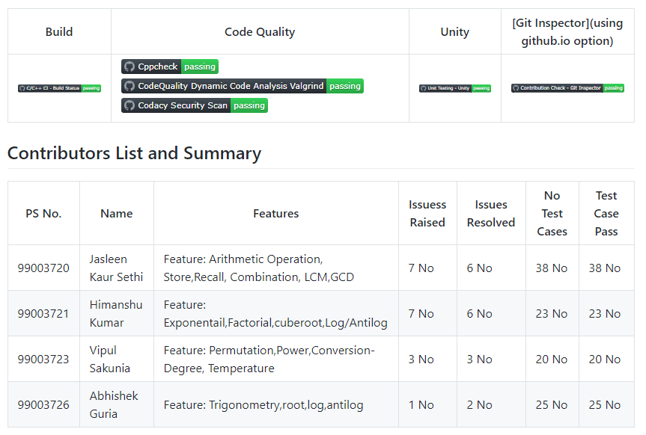

Summary
This project started with the research on the various calculators in the market, its age and its features. Then the requirements for our custom calculator was documented in the form of high level and low-level requirements. After the formulation of requirements, the design was made using the UML diagrams for the visual understanding of how the calculator software must be executed. After that, all the features required by the calculator are created in the form of C codes. The codes are then tested with all the possible test cases and error detection and correction is done. All the multiple files along with the headers are then executed and run with the help of a Makefile. Various building, CPP Checks and Unity testing is then done on the codes and badges for these workflows are finally attained.

Git inspector summary
“In linux install gitinspector and Run the command –
gitinspector -H -l -m -T -w -r --grading --format=html > gitinsp.html
and upload the same to your repo and paste the snapshot in the report”

Build
“Brief on outcome of the build and setup done”

Setup done

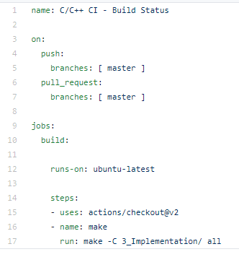

Outcome

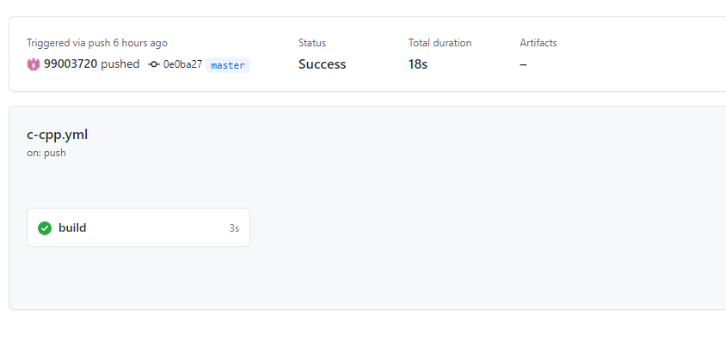
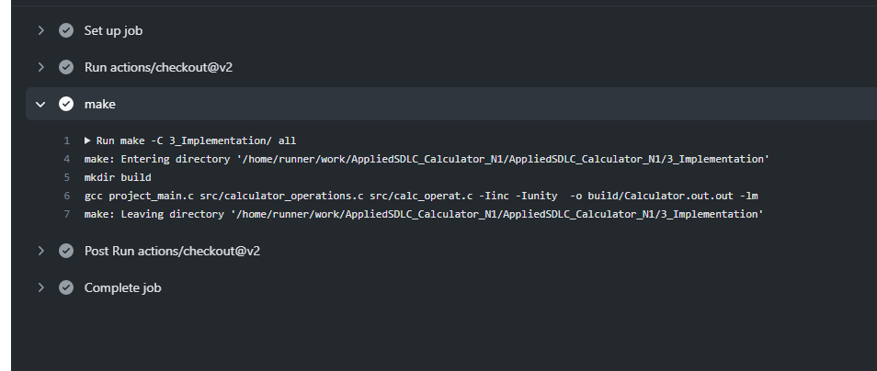

Code quality and Issues or Bug Tracking
“Brief on code quality, errors and warnings flagged (issues created) and fixed”
Setup Alignment

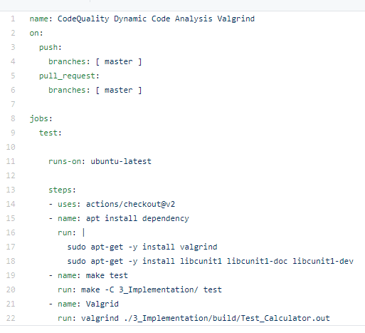

Outcome

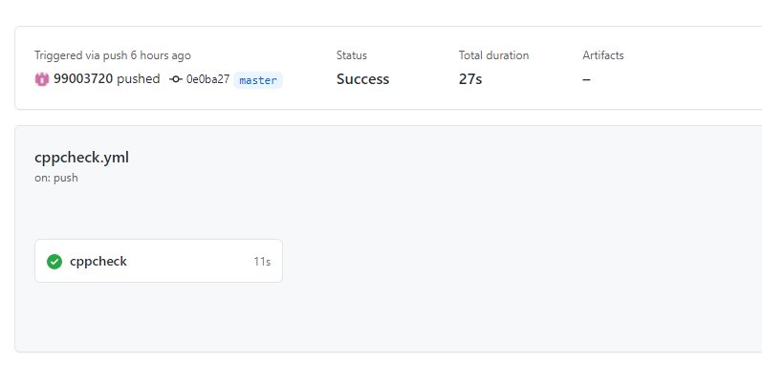
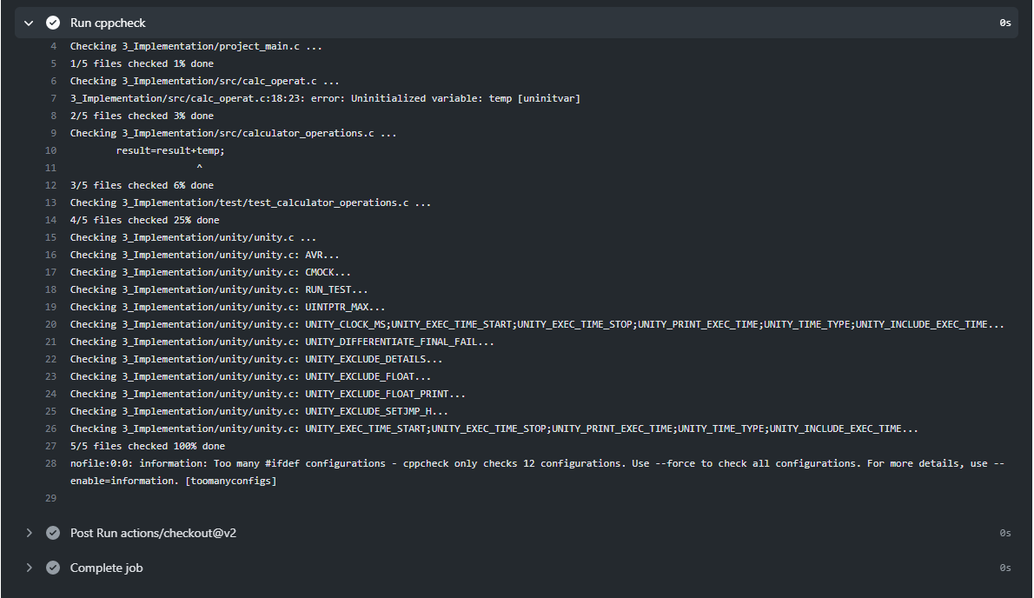

Unit Testing
“Unit Testing setup alignment with test plans and summary of outcome”

Setup Alignment

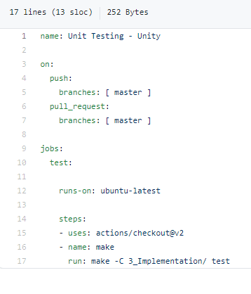
Outcome

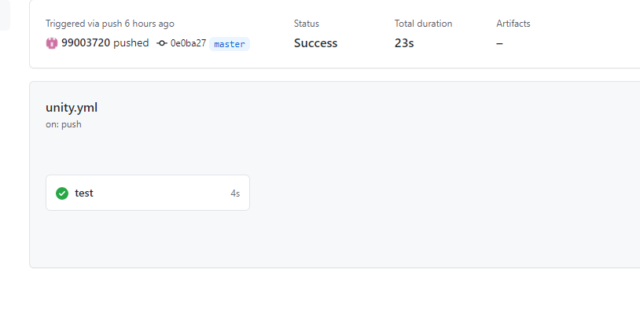

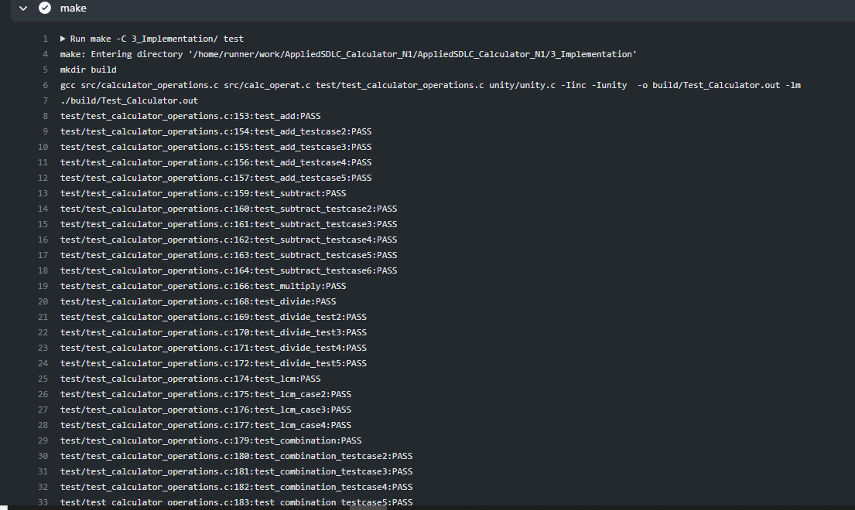
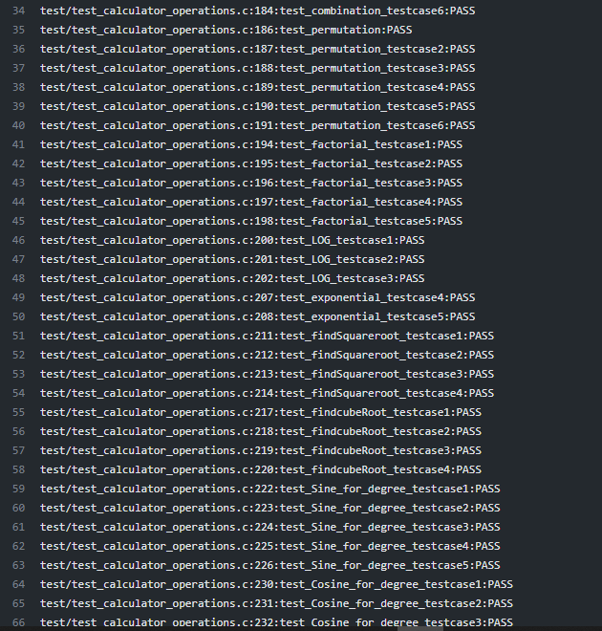
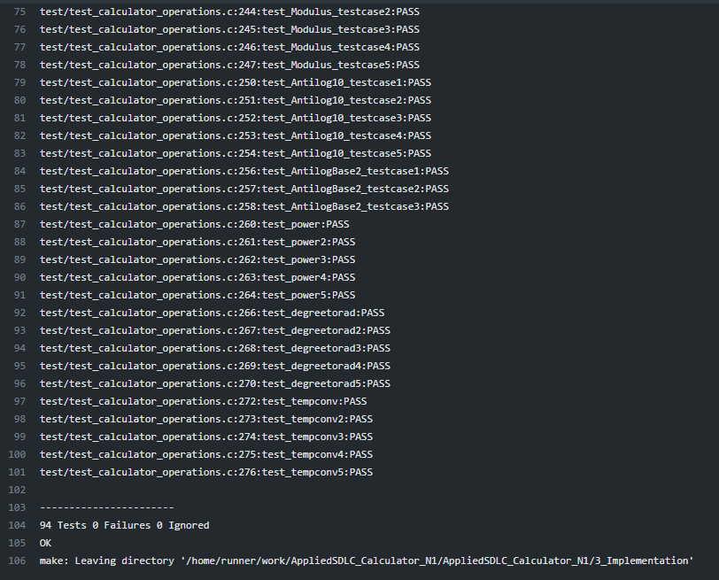

Individual Contribution & Highlights
The features implemented by me are:

Arithmetic Operations

- Requirements on various arithmetic operations as addition, subtraction, multiple and division.
- The low-level design for the operations
- Various test cases for the operations including all kinds of requirements

Permutation and Combination

    - Requirements and design for the permutation and combination functions
    - Implemented code for permutation and combination of two positive numbers

LCM and GCD
    - Requirements and design for the LCM and GCD functions
    - Implemented code for LCM and GCD of two positive numbers

Summary
“Key Highlights not covered till now, Softskills and technical side”

Challenges faced and how were they overcome
“Brief and crisp”

Future Scope (If applicable)

Miniproject -2 [Team/Individual]

Module/s
The modules linked to the mini project is SDLC and Python.

Topic and Subtopics

Objectives & Requirements
Objective:

The objective of the project is to extract the data present in different spreadsheets in different directories as required by the user by different paths given by him. The program scrolls through all the spreadsheets with the following data common in all the sheets:
- Name
- PS Number
- Email Id
The corresponding data must then be printed on the console as well as written to the excel sheet.

Requirements:

High Level Requirements:

ID | Requirements | Description | Status
HL001 | Providing Path | Path for the excel data is provided by the user | IMPLEMENTED
HL002 | Searching Data | Search all data from 5 sheets when user defines the name, PS number and email ID to be searched. | IMPLEMENTED
HL003 | writing to excel | Write all the data from different spreadsheet in one master sheet in a new excel sheet. | IMPLEMENTED
HL004 | extracting user defined data | Write new user required data in the excel file. | IMPLEMENTED

Low Level Requirements:

ID | Requirements | Description | Status
LL001 | Searching Data by user | The data to be searched is defined by the user. | IMPLEMENTED
LL002 | Searching Data according to the path provided | Data is present in different excel files present in different directories | IMPLEMENTED
LL003 | Search Parameters | The user defines the Name, email ID and PS Number of the data to be searched in 4*10 rows and columns per sheet | IMPLEMENTED
LL004 | Extracting user defined data | Data defined by user must be extracted from 5 different spreadsheets and put into one master sheet. | IMPLEMENTED
LL005 | Printing extracted data | 10 different data to be printed to the console. | IMPLEMENTED

Design
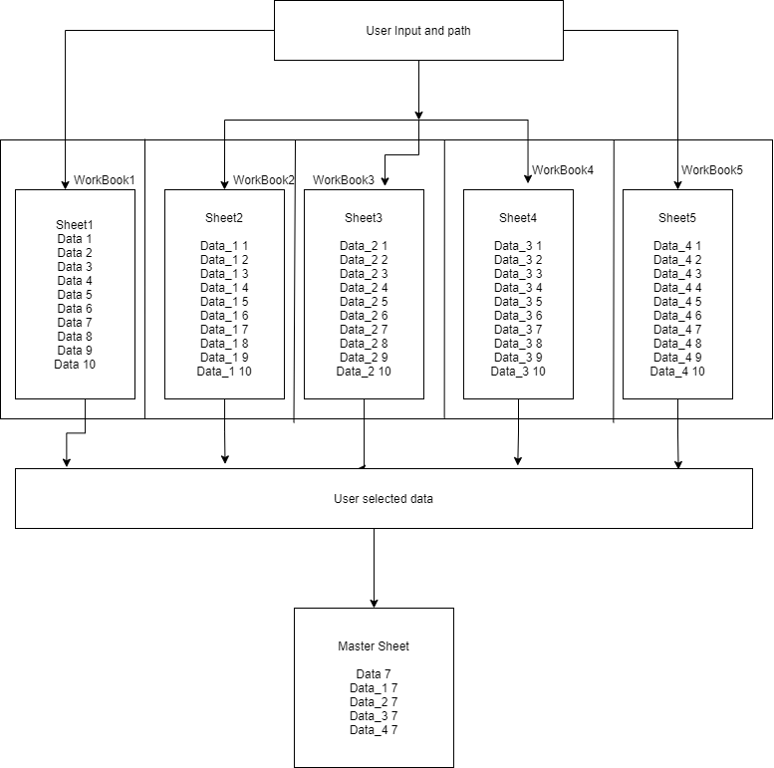
Structural – Interaction Overview Diagram
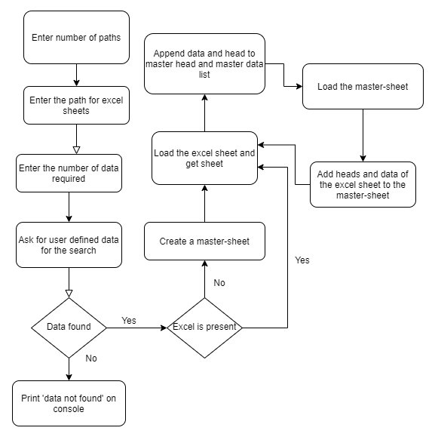
Behavioral – Activity Diagram

Test Plan
Test ID | Description | Expected Input | Expected Output | Actual Output
PY01 | The user defines the name in the common data for segregation of data required | Evan | The data corresponding to Evan in all excel sheets to a master sheet | The data corresponding to Evan in all excel sheets to a master sheet
PY02 | The user defines the PS Number in the common data for segregation of data required | 99003720 | The data corresponding to 99003720 in all excel sheets to a master sheet | The data corresponding to 99003720 in all excel sheets to a master sheet
PY03 | The user defines the Email ID in the common data for segregation of data required | evan.zigomalas@gmail.com | The data corresponding to Email ID in all excel sheets to a master sheet | The data corresponding to Email ID in all excel sheets to a master sheet
PY04 | The user defines the name and PS Number in the common data for segregation of data required | Evan and 99003720 | The data corresponding to name and PS Number in all excel sheets to a master sheet | The data corresponding to name and PS Number in all excel sheets to a master sheet
PY05 | The user defines the name and Email ID in the common data for segregation of data required | Evan and evan.zigomalas@gmail.com | The data corresponding to Evan in all excel sheets to a master sheet | The data corresponding to Evan in all excel sheets to a master sheet
PY06 | The user defines the PS Number and Email ID in the common data for segregation of data required | 99003720 and evan.zigomalas@gmail.com | The data corresponding to PS Number and Email ID in all excel sheets to a master sheet | The data corresponding to PS Number and Email ID in all excel sheets to a master sheet
PY07 | The user defines all the three, Name, PS Number and Email ID in the common data for segregation of data required | evan.zigomalas@gmail.com, 99003720 and Evan | The data corresponding to Name, PS Number and Email ID in all excel sheets to a master sheet | The data corresponding to Name, PS Number and Email ID in all excel sheets to a master sheet
PY08 | Incorrect path is provided by the user. | C:\Users\99003720\Desktop\pythonProject | Path not found | Path not found
PY09 | Incorrect common data provided | Jasleen and 99003720 | DATA NOT FOUND | DATA NOT FOUND

Implementation Summary
The user defines the common data that he can provide for the data to be searched. This data can be:
- Name
- PS Number
- Email ID
The python program then reads the data corresponding to the data from different spreadsheets of excel present according to the path of the main excel sheet provided by the user. It then creates a master sheet in another excel file and adds the data from all the sheets to it. In the end, the data to be provided to the user is printed to the console as well as written to the excel.

Git Link
https://github.com/99003720/Python_mini_project

Git Dashboard
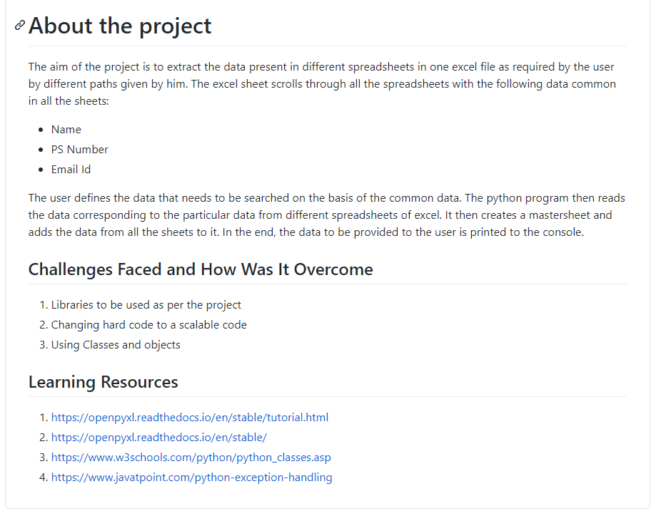

Summary

Git inspector summary

Build

Code quality

Unit Testing

Issues

Individual Contribution & Highlights

Summary
In this python project, 3 spreadsheets contain employee data in 40 rows and 10 columns. The python program asks for the number of data that needs to be put to the master sheet. The user provides one, two or three of the common data – Name, PS Number and Email ID. He also provides the path of all the spreadsheets that has all the data. The python program then searches the data according to the data provided. It then creates a master sheet and adds the corresponding data to the master sheet until the number of data to be written are over. All the data is finally printed to the console and written to the excel sheet.

Challenges faced and how were they overcome

Team Video different by everyone
Build, code quality, unit testing
How many mini projects

